Regular Expressions and Transition Diagram for PLATYPUS
Mark Kaganovsky

VID = AVID | SVID | AVID = L (L | D) * | SVID = AVID# | L = [a-zA-Z] | D = [0-9]
IL = DIL | OIL | DIL = 0 | NzDD* | NzD = [1-9] |  | OD = [0-7]
FPL = DIL.D* = (0 | NzDD*).D* | OIL = 00 | 0 OD+ | NzOD = [1-7]

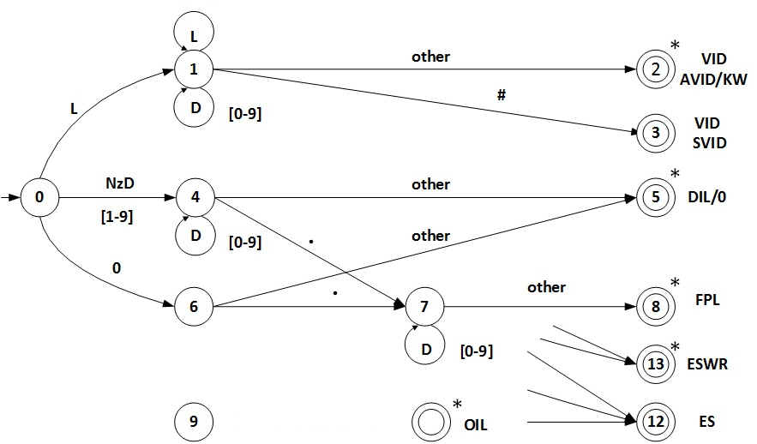

Transition Table
Current  State | INPUT SYMBOL |  |  |  |  |  |  | State Type  (Not Accepting or Accepting State)
Current  State | [a-zA-z] | 0 | [1-7] | [8-9] | . | # | other | State Type  (Not Accepting or Accepting State)
0 | 1 | 6 | 4 | 4 | IS | IS | IS | NOAS
1 | 1 | 1 | 1 | 1 | 2 | 3 | 2 | NOAS
2 | IS | IS | IS | IS | IS | IS | IS | VID AVID/KW - ASWR
3 | IS | IS | IS | IS | IS | IS | IS | VID SVID - ASNR
4 | ES | 4 | 4 | 4 | 7 | 5 | 5 | NOAS
5 | IS | IS | IS | IS | IS | IS | IS | DIL - ASWR
6 | ES | 10 | 9 | ES | 7 | ES | 5 | NOAS
7 | 8 | 7 | 7 | 7 | 8 | 8 | 8 | NOAS
8 | IS | IS | IS | IS | IS | IS | IS | FPL - ASWR
9 | ES | 9 | 9 | ES | ES | ES | 11 | NOAS
10 | ES | ES | ES | ES | 11 | ES | 11 | NOAS
11 | IS | IS | IS | IS | IS | IS | IS | OIL - ASWR
12 | IS | IS | IS | IS | IS | IS | IS | ES - ASNR
13 | IS | IS | IS | IS | IS | IS | IS | ESWR - ASWR

IS – Illegal State ES – Error State ES/AS – Error State or Accepting State
NOAS – Not Accepting State
ASWR - Accepting State With Retract ASNR - Accepting State No Retract

